**Technical Specification**

**Bakarry Aluminium & Glass Door & Windows Factory WEBSITE REQUIREMENTS**

**[Put the proper date here (date the work was due)]**

**Revision History**

|  |  |  |  |
| --- | --- | --- | --- |
| Date | Version | Author | Description |
| 5/27/22 | 1.0 | Comfort F. Zayzay | Site developer |
|  |  |  |  |
|  |  |  |  |

**Approval History**

|  |  |  |  |
| --- | --- | --- | --- |
| Name | Title | Signature | Date |
|  |  |  |  |
|  |  |  |  |
|  |  |  |  |

**DOCUMENT OVERVIEW**

This document is a technical document with all the information on the site that is to be created for the **Bakarry Aluminium & Glass Door & Windows Factory**

The document outlines all the technical and non-technical requirements.

**PURPOSE**

This document will help the **Bakarry Aluminium & Glass Door & Windows Factory.** management get understanding on the project while under development. **Bakarry Aluminium & Glass Door & Windows Factory gave** the various requirements for the site that is to be built. The company wants a site that will be simple and user friendly. The site is to have all the latest products on sale from the company. The site will also deliver a way for clients to contact the company.

**PRODUCT DESCRIPTION AND OVERVIEW**

**The site will have to support a means for** advertising products and services **and also have a back-end email address to help facilitate information transfer. The site will have a form for** customers and other people to send in messages, comment on the site, make purchasing and express feedback**. The site will give a brief history of the company and outline its vision.**

**PRODUCT OBJECTIVES**

The site main objectives are as follows:

* Customers and other people to send in messages, comment on the site, make purchasing and express feedback
* Advertising of products and services
* Get investors to invest in the company

**PRODUCT SCOPE**

The scope of this **Site** shall be as follow:

* Advertisement
* Selling of company products and services
* Interactive chart form

**PRODUCT ARCHITECTURE**

**Bakarry Aluminium & Glass Door & Windows Factory Site Architecture**

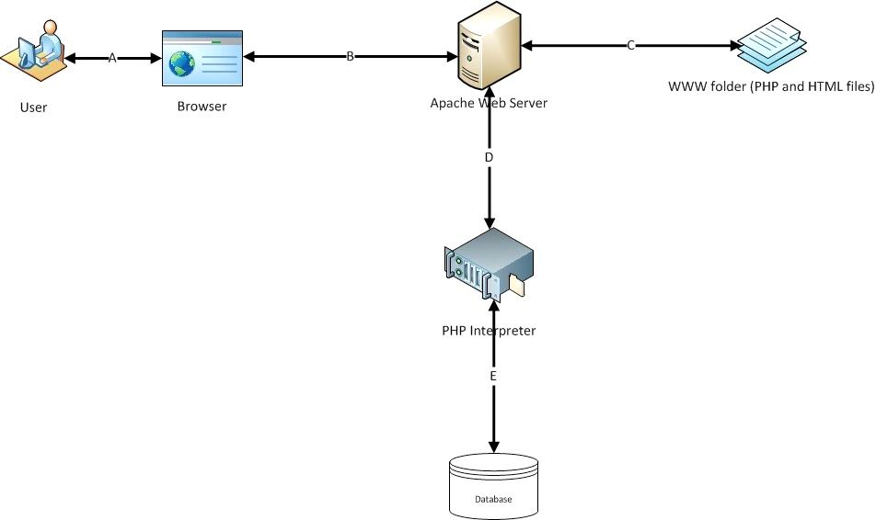

Figure 1.1 Architecture diagram of the proposed site

**PRODUCT FEATURES**

**Diagram Representation of features of the Proposed Site**

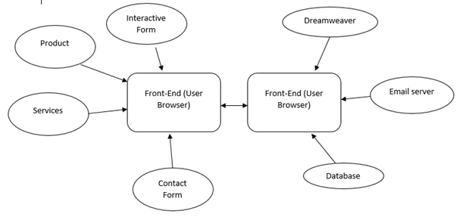

**Figure 1.2 Diagram of features of the proposed site**

**Below is a brief description on the features mentioned in the diagram drawn above:**

**Front-End**

* **Interactive Form – this is going to serve the purpose of users sending messages to the company through the site.**
* **Product – this is going to serve as a means for the public to be aware of the different products of the company.**
* **Services – this is going to serve as a means for end users to see services render by the company.**
* **Contact Form – this is going to allow users to contact for company for any inquiry.**

**Back-End**

* Database – Provide validation, interaction, data storage and other function of the site with the aid of PHP.
* Email Server – Provide basic email services to the site
* Dreamweaver – this is the content management system the site is going to be administrated through.

**PRODUCT TECHNICAL REQUIRMENTS**

**The Church’s site** shall be built using the following requirements:

* Hardware

The hardware interfaces and its recommended minimum specification are described as follow:

|  |  |
| --- | --- |
| PCs/Laptops | 8GB Ram, 1TB HDD |

* Software

The software interfaces to be used for development and its recommended minimum specification are described as follow:

|  |  |
| --- | --- |
| Web Server | Apache HTTP Server |
| Microsoft SQL Server | At least 2008 R2 |
| PHP, HTML5, CSS, JavaScript | At least revised code from 2015 |

* Communication

The communication interface shall be WAN that supports TCP/IP and SMPP protocols.

**USER PROFILE**

The typical users of **Bakarry Aluminium & Glass Door & Windows Factory site** are presumed to be:

* Investors
* Customers in need of products and services

**GENERAL ASSUMPTIONS AND CONSTRAINTS**

The potential assumptions and constraints in the successful design and implementation of the **site** are as follows:

* The site should have a professional look
* The site should be user friendly
* The site should be quick to load
* The site should be easily navigable
* The site should have a fast response rate
* The site should be fully functional at all time
* The site should be up to date
* The site should be safe from hackers

**PRODUCT DOCUMENTATION**

**After the development of the site, the developer shall present the below documentation:**

* **User Manual (guide)**

**The developer shall also carry out additional training for some employees to be able to operate the site.**

**DEPENDENCIES**

* **The site must be online 24/7 and fully functional at all times**
* **The site must have a person dedicated to replying to messages received from the contact form**
* The site must have database and power backup, and recovery strategies
* The site must be able to adjust to any browser without break of content
* **The site** must be multi-platform savvy
* The site must be able to work on different devices no matter the specs

**NON-FUNCTIONAL REQUIREMENTS**

|  |  |
| --- | --- |
| User Feedback and monitoring | **The site must be able to give a report of the user feedback on its performance in order for the administrator to make improvements where need be.** |

**PROJECT FUTURE SCOPE**

**For the future scope of the site, the below functionalities are to be added:**

* **Customers profile management**
* **Company user and customers login**
* **Company activities management**
* **Company financial record reporting and management**

**IMPLEMENTATION ACTION PLAN**

**The Bakarry Aluminium & Glass Door & Windows Factory** is estimated to be completed before the First Semester 2022.

|  |  |  |  |  |  |
| --- | --- | --- | --- | --- | --- |
| **STEP** | **OBJECTIVE** | **METHOD/TOOL** | **DELIVERABLE** | **DURATION** | **REVIEW MEETING** |
| Three | Site Diagram and Page description diagrams | Microsoft office | Diagram of the site | 4 days |  |
| Four | Site Development | Adobe Dreamweaver | First prototype of the site | 2weeks |  |
| Five | Testing | Web Browser | Feedback from the church and the instructor | 1 week |  |
| Six | Refined site | Adobe Dreamweaver | Final site from the developer | 1Week |  |
| Seven | Delivery | Server | Files and server configuration | 1week |  |
| Eight | Feedback and performance monitoring | Google analytics, feedback forms, etc. | Report from the site operation and success | continuous |  |